The week of January 25, 2021
Outdoor Report

- Ice depths vary. There are still quite a few areas of open water. Please use extreme caution if you decide to venture out; bring appropriate safety gear and don’t go alone.
- Conservation Officers have been receiving many complaints of trespassing to get on to area lakes, parking on private property and parking on roads creating traffic hazards. Please be courteous. Ask permission.

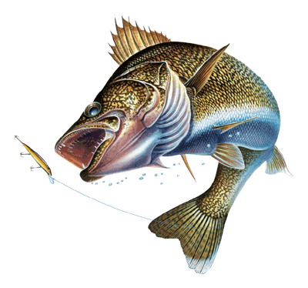
Aberdeen Area
Fishing Report
Richmond: There is still open water by the north and west bridges. Anglers have been catching some perch, crappie, and walleye.
Mina: Anglers have been catching small perch and walleye. The ice by the east boat ramp is only 2-4 inches.
Elm: There are weak spots by the resort bridge and west arm of the lake. Anglers have been catching some perch and walleye.
Hosmer Slough: Anglers have been catching some small perch.
James and Elm Rivers: The ice is not safe to fish.

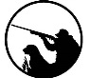
Hunting Report
Pheasants: Hunters that are walking cattail sloughs are having the best luck.
Squirrel and rabbit: The cottontail rabbit and tree squirrel seasons are open until Feb 28, 2021. With the mild winter this is a great time to get a young hunter in the field.

Clark County
Fishing Report
Dry 2: Another week of two outfits going through the ice. Always make sure of ice conditions and use extra caution. Still some walleye and perch getting caught.
Dry 1: Perch bite is hit and miss right now. A lot of moving around and you may be able to find the small schools. Some walleye getting caught early and late days.
Reid: Smaller perch being caught with some nice walleye as well.

Codington County
Fishing Report
Goose: Fishermen are catching 13-15 inch walleye. The State ramp in the NW corner of the lake is now open for use.
Kampeska: Fishermen are catching a few walleye, blue gill, perch and crappies.
Pelican Lake: Little fishing activity. There is an area of open water that extends from the State Park to the north shore.
Blythe Slough: Fishermen are catching a few perch and walleye. A gravel launch has been added in the NW corner of the lake.
Long Lake: Fishing has been hit or miss. Fishermen are catching 15-18 inch walleye and the occasional perch at times.
Dry Lake: Fishermen are catching northern pike.
Hunting Report

Pheasant: Hunters are averaging about 2– 2.5 birds per hunter this past week.

Day County
Fishing Report
Waubay: Angler pressure has been steady with anglers having some success on white bass, walleye and perch.
Bitter: Fishing was slow this last weekend with the front that passed through. Anglers struggled to find much for perch or walleye.
Pickerel: A few anglers are still having some success catching crappie and bluegill with the occasional walleye.
Hunting Report
Pheasant: Pheasant season comes to an end at sunset January 31st. Take this last week to get out and enjoy some late season rooster hunting.
Hamlin County
Fishing Report

Poinsett: Anglers have reported a few walleye and perch being caught.
Albert: Minimal traffic as of right now.

Marshall County
Fishing Report

Roy: Good pike fishing near the resort using tip ups.
Clear: Anglers have found a few panfish and the occasional walleye.
White: Crappie and walleyes have been caught in the mornings and evenings.
Opitz: A few small walleyes and a few perch are being caught.
Buffalo lakes: A few panfish and pike have been caught.
Piyas: Decent walleye and perch bite near main lake points.
Hunting Report
Pheasant: Hunters focusing on cattails near harvested fields seems to be having the best success.

Park Report:

- Don’t let the cold weather deter you from getting out and enjoying our State Parks! As always, our parks are open year-round so take some time to get out and enjoy South Dakota’s State Parks! The electricity is on year-round and the camping cabins and lodges have heat. Reservations can be made at campsd.com or 1-800-710-2267.
- The 2021 Park Entrance License is currently for sale. Pick yours up today at any of our participating vendors in Watertown, Aberdeen and surrounding areas. These include The Cowboy Country Stores, Hy-Vee, Little River City, Gas n Goodies and the GFP office in Watertown. Aberdeen vendors include Ken’s Superfair Foods, Runnings, Kessler’s, and any GFP office.

Pelican Lake Recreation Area
- Back by popular demand... OPERATION ADVENTURE! Join us on our 19-week, 10 program series designed for the families that love the outdoors or are ready to get involved. Every other Thursday throughout the series, we will cover diverse outdoor recreation topics that everyone can learn from, whether you're a beginner or a lifelong sportsman. Programs go from 6-7:30 PM. All equipment will be provided. Join us January 28th for Winter Survival. We will meet at the picnic shelter.
Oakwood Lakes State Park
- Join us at Oakwood Lakes for the annual Cool Kids Classic Fishing Derby on Saturday, January 30th! Registration runs from 10am – 11am on Oakwood East with fishing from 11am – 12:30pm. Changes have been made to the program this year to follow covid-19 safety measures. One of those changes is with the Liability Waiver. This can be signed ahead of the event by going to www.eventbrite.com and registering for the Cool Kids Classic Ice Fishing Derby. You will need to use Chrome or Microsoft Edge; Internet Explorer will not work. Contact us at 605-627-5441 for more info or with questions.

