The week of May 18, 2020
Outdoor Report

- State offices are currently closed to proactively help slow the spread of COVID-19. If you need assistance during this time, you can contact your local Conservation Officer, State Radio at 353-7132 or the TIPs Hotline at 1-888-OVERBAG.

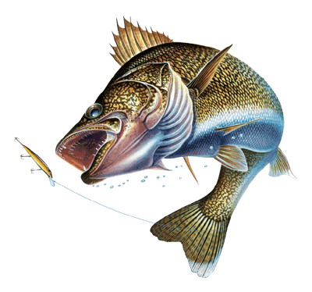
Aberdeen Area
Fishing Report
Richmond: Anglers are catching some walleye, occasional perch, and white bass. The walleye bite has been better in the evenings.
Elm: Anglers have been catching walleye and some northern pike.
Elm River: Anglers have been catching some walleye and northern pike. Anglers have been fishing below the Elm Lake spillway, and Kruse’s Dam.
James River: Anglers are catching walleye and some northern pike. The fishing has been better up in the Sand Lake area, and by Hecla.
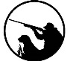
Hunting Report
Turkey: The archery turkey season in open until May 31st. In Brown County we only have an archery turkey season.

Clark County
Fishing Report
Dry 1: Doing well for 12-16 inch walleye. A lot of anglers are wader fishing the county road grade on the NE end of lake but is highly crowed so get to your spot early. Some boat activity as well, but the access spot on the east/west road is very rough and troublesome. Be prepared with a tow rope and extra muscle to winch the boat all the way on. I don’t recommend any bunk trailers or heavy boats.
Dry 2: Still seeing a few boats launching off the Willow Lake Rd. Fishing got a little more difficult with cooler water, but some nice fish being caught.
Indian Springs: Seeing the brunt of boat activity in Clark County. Fishing success is all dependent on what boat you speak with. Some are finding a few fish, and some are striking out with no bites at all.
Swan: Saw some boat anglers over the weekend. Didn’t speak with anybody that had any real success on the lake. Very clear water and hard to fish.

Codington County
Fishing Report
Goose: Fishermen are catching walleye from shore and by boat.
Blythe: Fishermen are catching walleye from shore. Most of which are over 20 inches.
Kampeska: Fishermen are catching a mixed bag of fish from shore and by boat, including (northern pike, white bass, perch, crappie and walleye.) The crappie bite is starting around the lake.
Pelican: Fishermen are catching walleye from shore and by boat, evenings and mornings seem to be the best times.
Hunting Report

Turkey: Toms are starting to break away from the hens and have become more receptive to calling.

Day County
Fishing Report
There have been a few changes in Day County for shore fishing. Due to the highwater and safety hazard of a vehicle and pedestrian accidents, the county is no longer allowing pedestrians on the Grenville grade, Day Co 1 north of Hwy 12 to 140th St., and Yellowstone trail from Main St. to Day Co 1. Also, if you are shore fishing make sure you are parked in a legal parking spot and it is not posted as no parking.
North Rush: Fishing pressure picked up a little this last week with anglers catching a few walleye and northern pike.
Blue Dog: Anglers are catching an occasional walleye.
Waubay: Good numbers of white bass and the occasional walleye are being caught.
Bitter: Little activity.

Hunting Report
Turkey: Plenty of opportunity still exists to harvest a turkey yet this season.

Hamlin County
Fishing Report

Poinsett: It was a rainy weekend causing fishing pressure to be slow. There were still a few fish being picked up. Mix bag of walleye and crappie. There is a 300ft NO-WAKE zone restriction around the entire lake.
Albert: Reports of a slow bite but quality walleye being caught.
Hunting Report
Turkey: Few hunters out this past weekend and success remains limited to the Sioux Poinsett GPA.

Marshall County
Fishing Report

Roy: A few walleyes being caught but overall slow.
Clear: A few walleyes and pike being caught from the Hwy 10 grade in flowing water next to the bridge.
White: A few walleyes being caught near the boat ramp area.
Opitz: Some walleyes being caught near the boat ramp and grade south of ramp.
Cattail: Some really nice walleye and bass being caught near timbered main lake points and shallow bays.

Hunting Report
Turkey: The birds are moving around a lot. Over the weekend hunters had good luck calling and utilizing decoys. The hens should start going to the nest here real soon and hunting could get even better. Most birds have been observed in the eastern portion of the county. Be sure to obtain permission before entering private land. Good luck and be safe!!

Park Report:

Pelican Lake Recreation Area:
- Check out our Facebook page @PelicanLakeSandyShore for E-Programs. On each post, you will find educational and interactive videos, daily challenges, and activity packets for a wide variety of ages for each lesson.
- Pelican Lake Recreation Area is hosting Becoming an Outdoor Family July 15-17. Registration is open. The event website with more information on the program and registration can be found at gfp.sd.gov/outdoors-family.
Fort Sisseton State Park:
- #FunFactFriday is still going on! Go on a video exploration of the Fort with our park manager Ali as she answers some of the most frequently asked questions and gives us insight on some of the fun and lesser known history of the area. Check out our Facebook page for #FunFactFriday.

